**Dictionary:**

- An unordered set of *key: value* pairs   
- Provides a way to map pieces of data to each other and allows for quick access to values associated with keys (keys must be immutable, either numbers or strings)  
- Values can be any type: string, number, list, even another dictionary  
- Created with curly braces *diner = {}* or using built in function *dict()* – diner = *dict()*  
- Can be accessed by passing the associated key name in a *dictionary[key]* syntax  
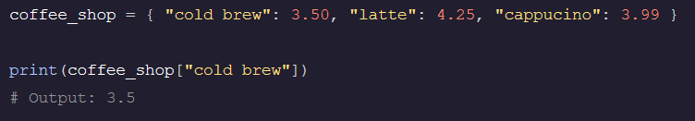  
  
- Can iterate through dictionaries by *key, value, key-value tuple,* and *individual key values*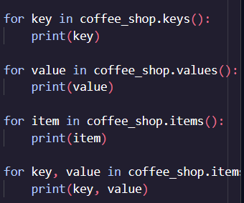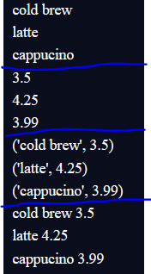  
- To replace a value in a dictionary call the variable name and use [] to indicate value being changed (cannot change key only value)  
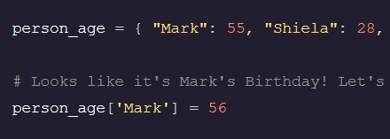

- Can also add *key: value* pairs to dictionary by using *dictionary[key] = value*- To add multiple *key: value* pairs at once we can use the *.update()* function 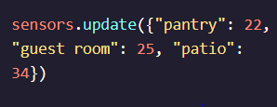

**Dictionary Comprehensions**

- Can combine two dictionaries using the *zip()* function  
- It zips them into a tuple (unmutable) and you need to do range() or for loop across the new file to print it properly  
